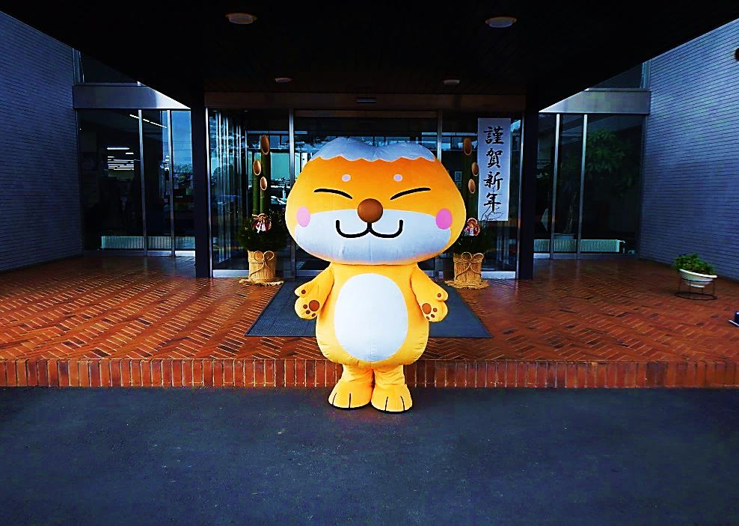

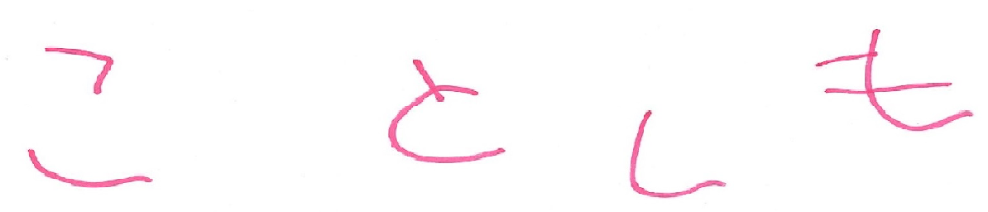

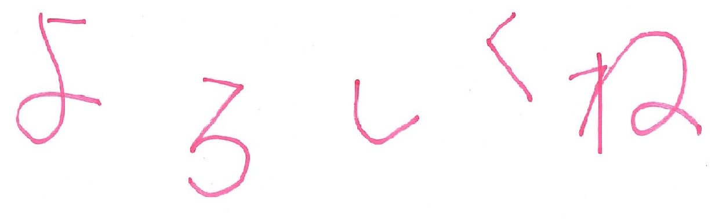

C:\Users\Admin\AppData\Local\Microsoft\Windows\Temporary Internet Files\Content.IE5\TVLGLAOE\gi01a201503090400[2].jpgC:\Users\Admin\AppData\Local\Microsoft\Windows\Temporary Internet Files\Content.IE5\TVLGLAOE\gi01a201503090400[2].jpgC:\Users\Admin\AppData\Local\Microsoft\Windows\Temporary Internet Files\Content.IE5\TVLGLAOE\gi01a201503090400[2].jpgC:\Users\Admin\AppData\Local\Microsoft\Windows\Temporary Internet Files\Content.IE5\TVLGLAOE\gi01a201503090400[2].jpgC:\Users\Admin\AppData\Local\Microsoft\Windows\Temporary Internet Files\Content.IE5\TVLGLAOE\gi01a201503090400[2].jpgC:\Users\Admin\AppData\Local\Microsoft\Windows\Temporary Internet Files\Content.IE5\TVLGLAOE\gi01a201503090400[2].jpg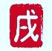C:\Users\Admin\AppData\Local\Microsoft\Windows\Temporary Internet Files\Content.IE5\TVLGLAOE\gi01a201503090400[2].jpgC:\Users\Admin\AppData\Local\Microsoft\Windows\Temporary Internet Files\Content.IE5\TVLGLAOE\gi01a201503090400[2].jpg

**あけまして**

**おめでとうございます**

ふたまたぎつね

福島県天栄村

**二〇一八年**